Observer Time Ratio X(z) — CFT vs GR

This figure compares the Chronotension Field Theory (CFT) prediction for the observer time ratio X(z) to the baseline assumption in General Relativity (GR).

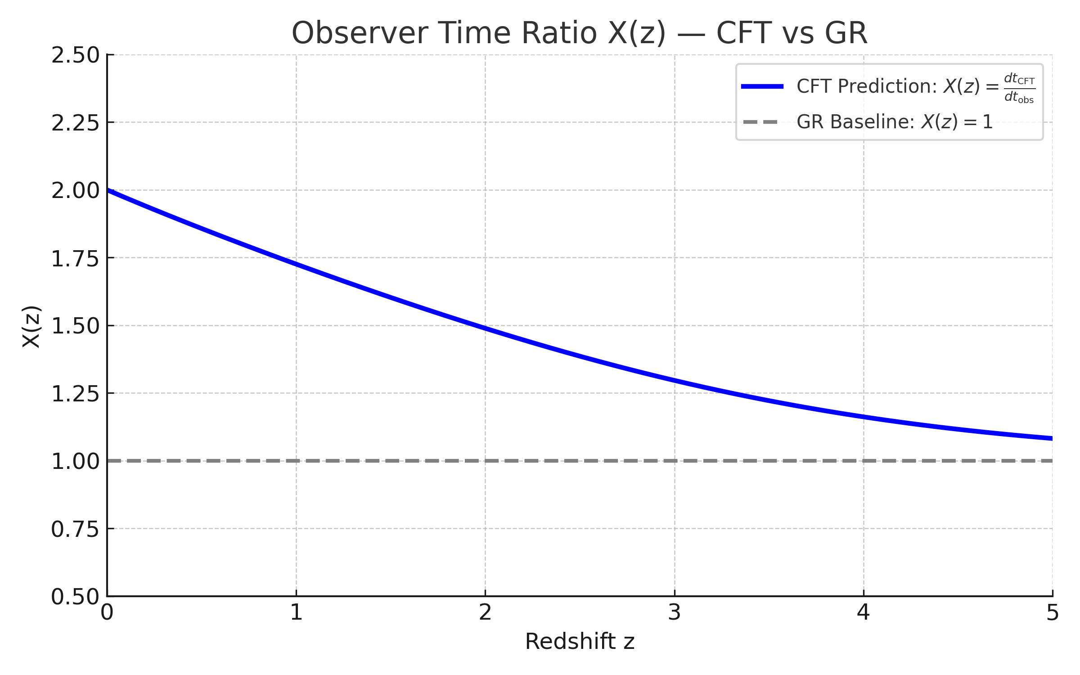

CFT predicts that cosmic time (dt_CFT) and observer time (dt_obs) diverge as redshift increases. This leads to X(z) > 1, meaning that distant events happened in less CFT-internal time than they appear to from an observational standpoint. GR, by contrast, assumes a constant time relationship (X(z) = 1).  
  
This difference explains previous mismatches between CFT and H(z) data and provides a critical correction mechanism that enables CFT to fit observational curves with greater accuracy.